-->

[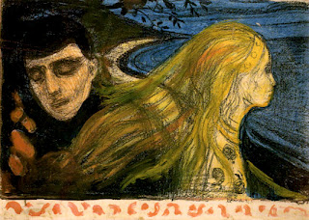](http://4.bp.blogspot.com/_c_oCoDXYEuc/TAjaV7Ybk2I/AAAAAAAAAOU/e7TLx_CciCE/s1600/separationII_litho_3.jpg)

-->

Treading on this road, there’s a curve approaching,

Unsteady gaze, pensive and unwilling, we give in,

As the world flashes by in front of my eyes,

I wonder, What becomes of us?

                        Why should I cry now, when we drift apart,

                        When there was no tear, when we once met?

                        Those moments shared, that uphill walk,

                        Our hearts seemed to be strung into the single thread;

How can I forget, that childish banter,

Those mocking scuffles, your chirpy chatter?

Over are those times when fighting was leisure,

And confiding little secrets, derived eternal pleasure;

Why should I cry now, when we drift apart,

                        When there was no tear, when we once met?

                        We fought, we got upset, but still held together,

                        There is no fight now, then what did happen?

Our paths, are entwined like a stranded helix,

No matter how much we twist,

No matter how hard we turn,

Our paths will cross, but never be one;

Why should I cry now, when we drift apart,

                        When there was no tear, when we once met?

                        Our roads diverge here, the curve’s been taken,

                        So till we next meet, Adieu, my friend!!